**ZH-ZXE Series Manual**

**I. Software Download**

Please download the software from the official website: www.zhonghangled.com/en

Software named: LED Player V5 ( 5.006.005.021 and the above version ).

This software realizes the data communication connection of the equipment, and realizes the software to set up and control the equipment.

**II. Hardware Connection**

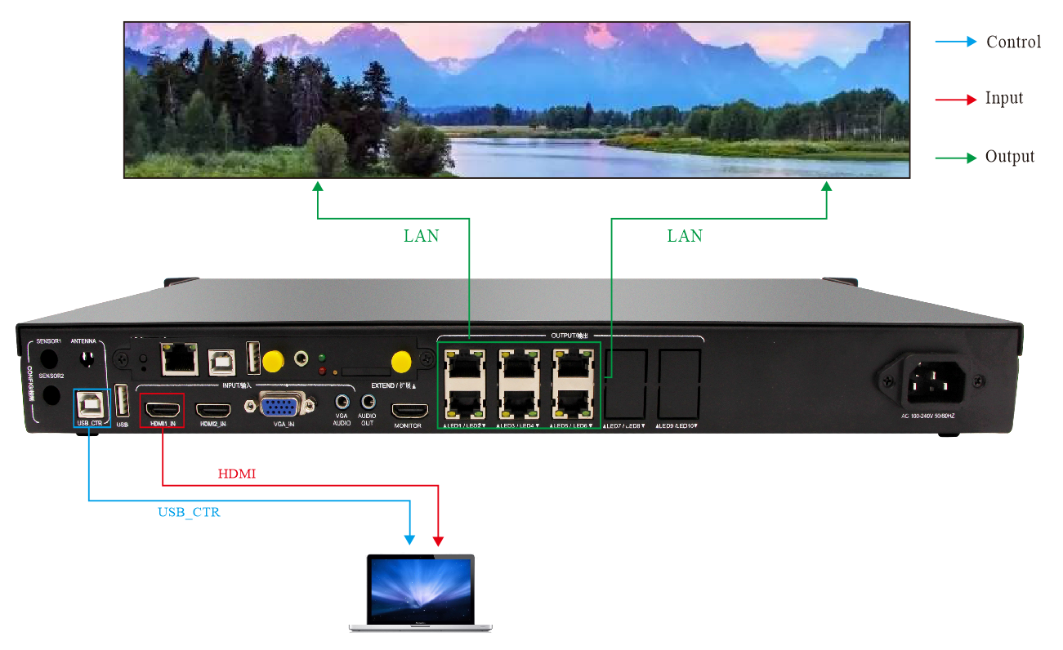

## **III. Screen Set**

When setting, you need to connect the computer's USB cable to the device for setting. Connect the computer's HDMI signal to the device to provide the signal source (you can also use the device's default signal source box, or VGA, etc.), and connect the network cable to the LED screen receiving card.

1. Open the software, select "Sync Mode" and click "Yes". (this prompt will appear when you first install the software and open it). Or you can switch from “Setting”---

“Software mode”

1. Click “ Setting ”---“ Display settings”

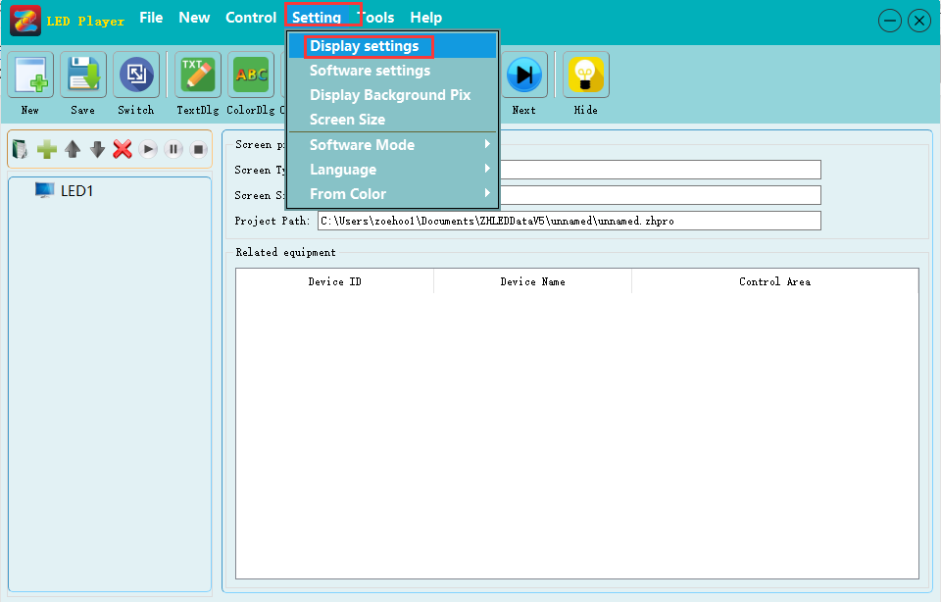

1. If the message in the red box is displayed, it means the device search is successful. Click "Display Settings" and enter the password "168".

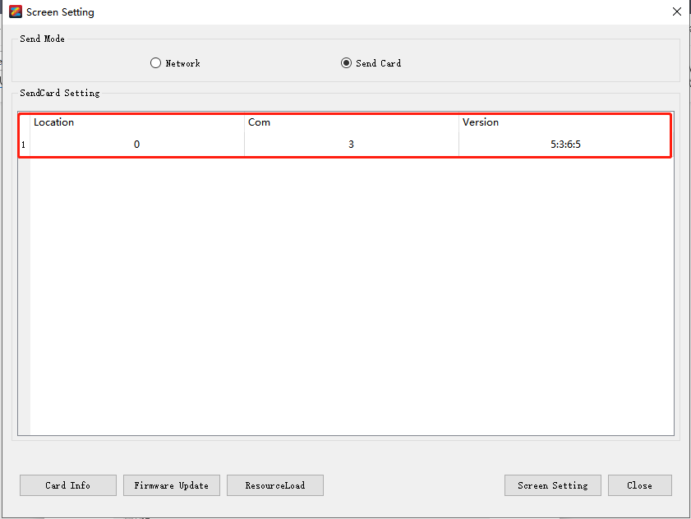

4. In the "INPUT-input selection" on the device, select the corresponding signal source button (the button light is always on to indicate that there is a signal, and the button light is flashing to indicate that there is no signal). And make sure that in the "Signal Source Settings" of the "Sending Card" interface, at least one signal shows "Signal"

(When using this device for the first time, please pay attention to the version of the receiving card. If you need to upgrade, please update in "Firmware Upgrade", or contact relevant technical person.)

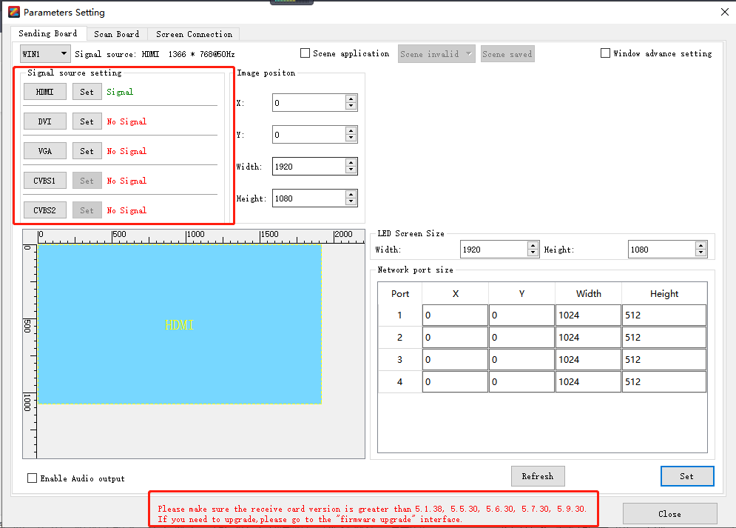

1. Click “ Receiving Card ”, select the suitable model type.

You can directly use the "Select Module" method to set (Or use the "Intelligent Setting"), set the "height" and "width" and click "send to hardware" and "save to hardware".

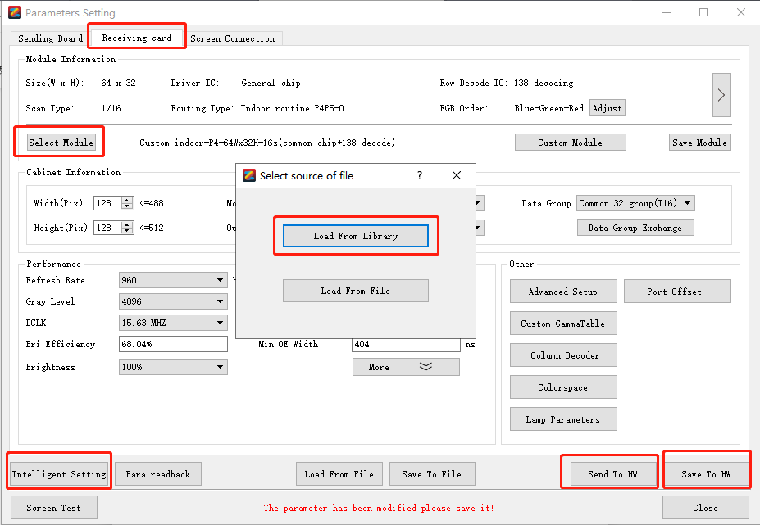

1. Select "Screen Connection" in the upper left corner, set "Scan Board Columns", "Scan Board Rows", and "Scan Board Size", then connect the network cables in the correct order, (Please Note: look at the LED screen from the front and look at the computer from the front in the same direction, just distinguish up, down, left and right). After the configuration is completed, click "Send to Hardware". After the screen is displayed normally, click "Save to Hardware" to complete the setting.

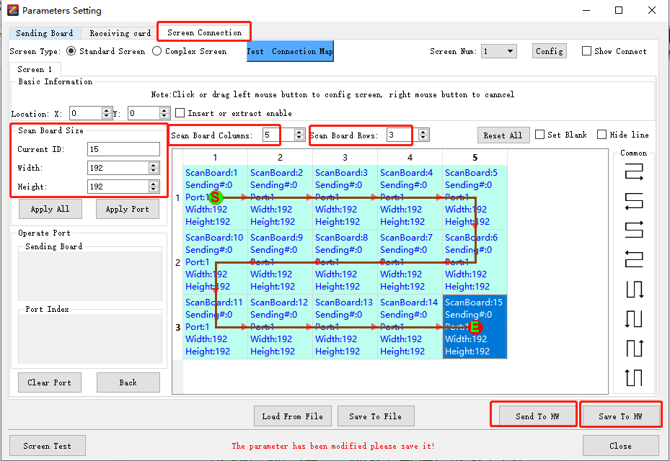

## **IV. Edit Content**

**1. Play in synchronous mode ( choose signal: HDMI1, HDMI2, VGA)**

**2. Play in asynchronous mode ( Setting-Software Mode--Asynchronous Mode, about the signal choose: “BOX”**

**3. Edit content**

Create program--File Window---Add material

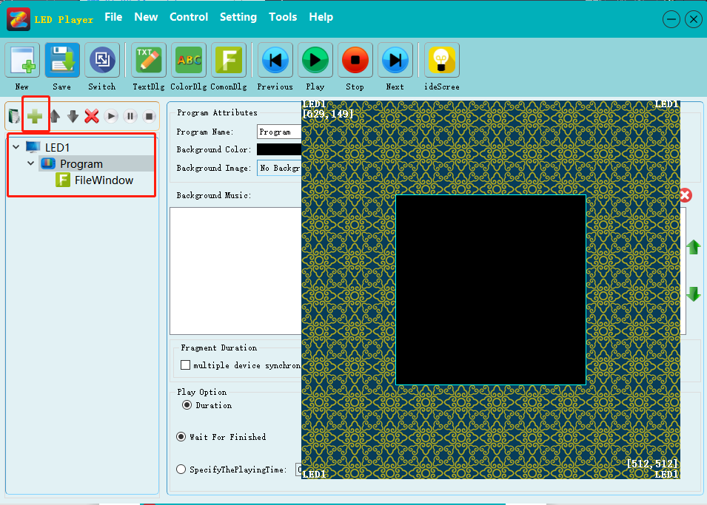

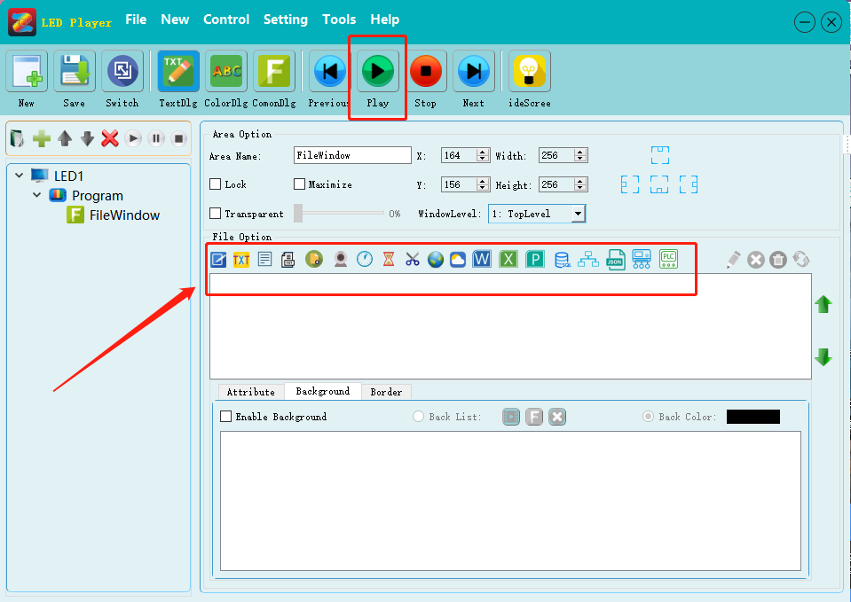

(Any material can be added under the "File Window", and it will be played in sequence during playback. Multiple "File windows" can be played in regions or superimposed, and you can click “Play” to preview the effect before uploading)

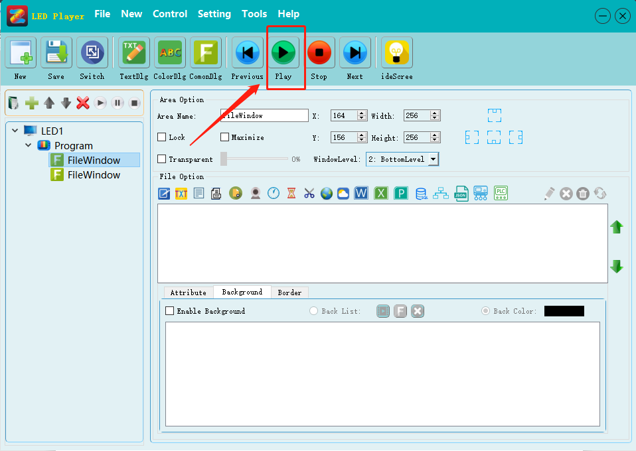

1. **Upload content by U-disk**

1). Click the "Export" button in the upper right corner of the software.

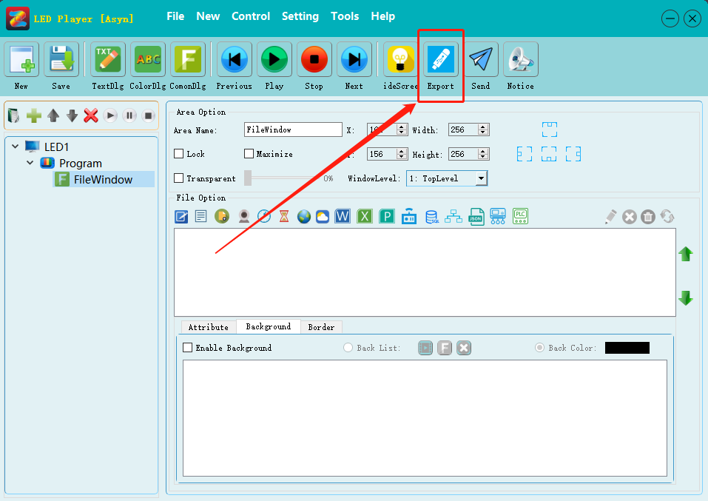

1. Enter "Dialog", if there is time to add, please check the "Time Correction" , and finally click "Export".

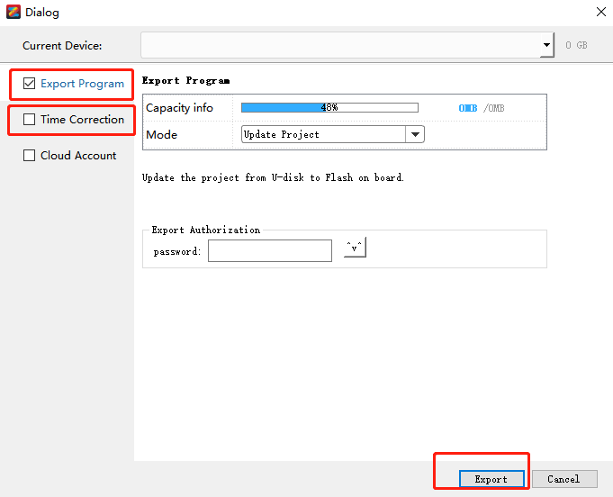

3). Wait for the backup to complete, click "OK" to unplug the U disk.

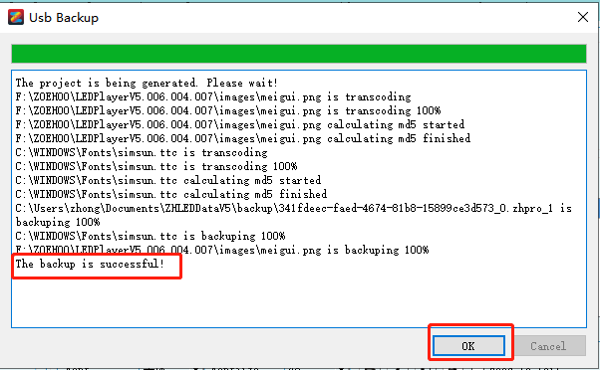

1. **LAN Cable Send Content**

1). Click the “Send” button in the top right corner of the software.

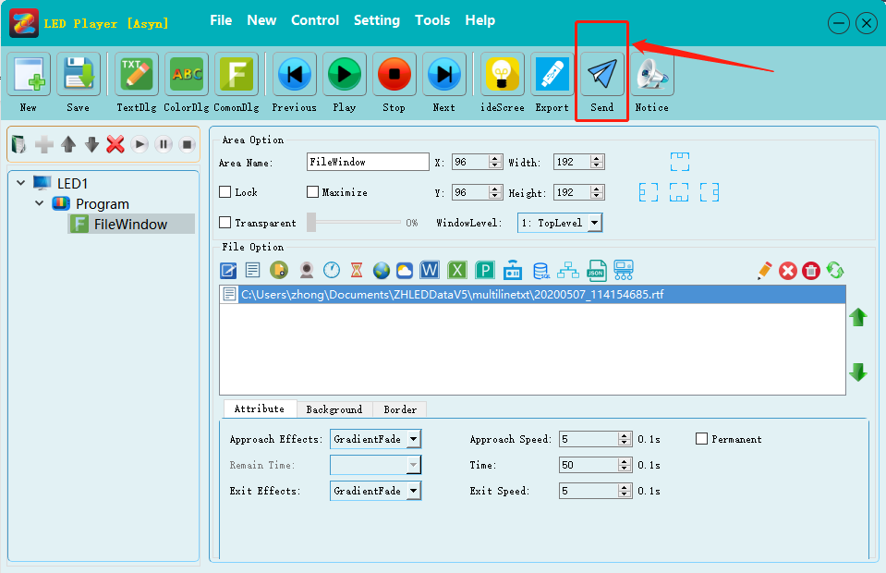

2). After the transcoding is completed, the “Cluster Sending” interface will pop up, select the corresponding device, and click “ Send ” to send the content.

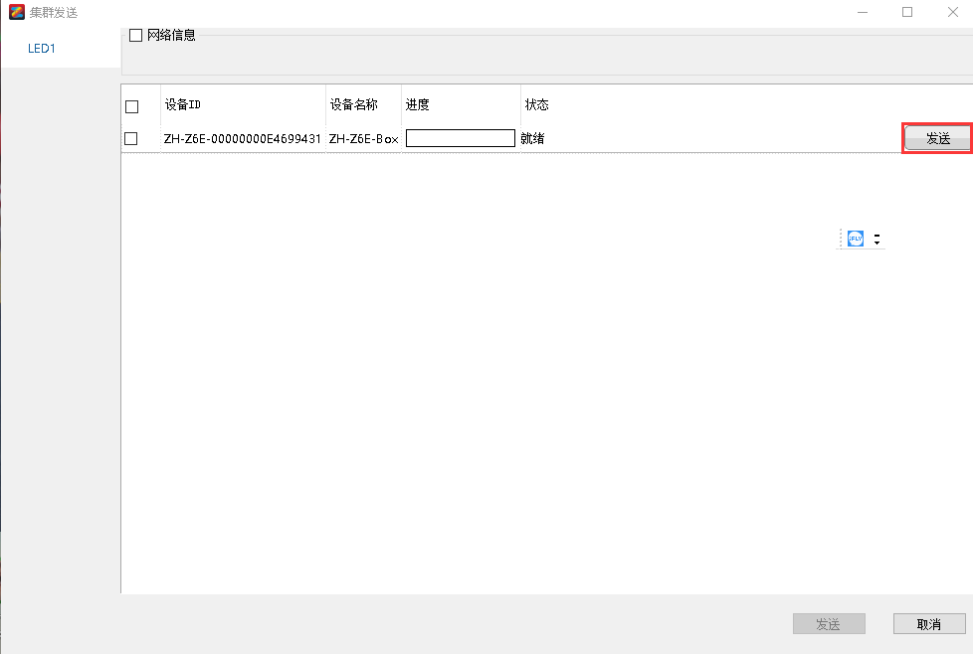

1. **WiFi Send Content**

Due to information security issues, the factory default WiFi is closed. Therefore, customers need to turn on WiFi manually. The steps are as follows:

1). Using Ethernet cable line to open WiFi:

① Click “Control--Asynchronous Management”.

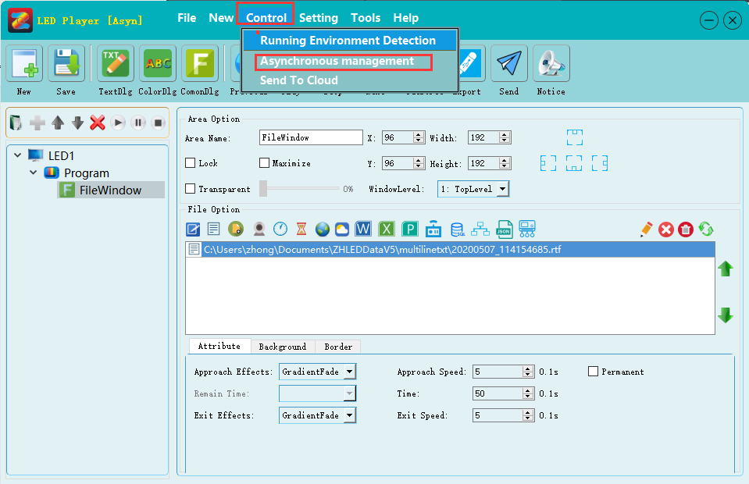

② Choose the device, and click “ WIFI setting ”

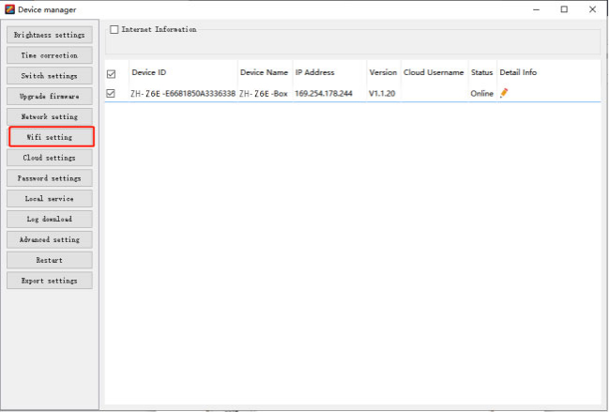

③ Choose “Enable”, make sure the WiFi name and password, then click “setting”.

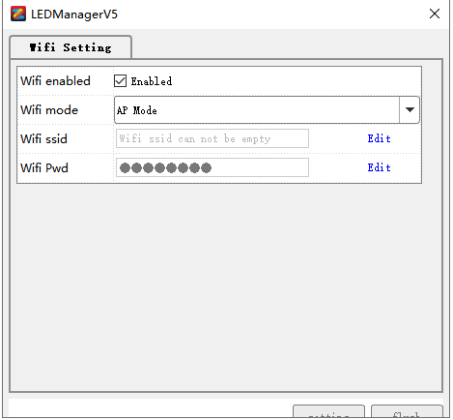

④ After link this WiFi can send content. (For the steps, please refer to the network cable sending)

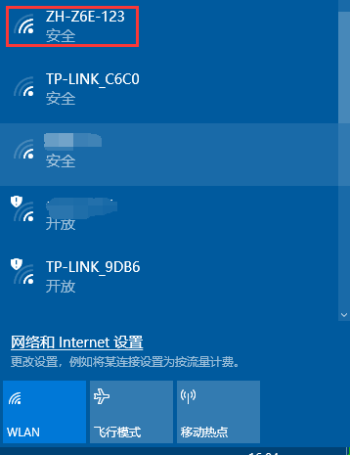

2). Using U-disk to open WiFi

① Click “Control--Asynchronous Management”.

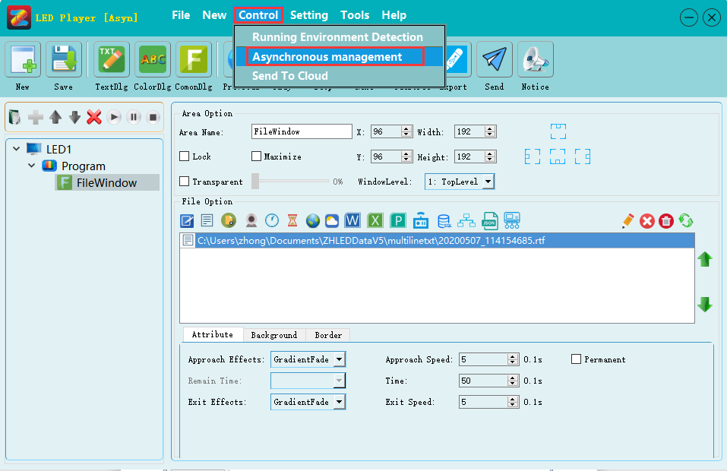

② Select the device and click “ Export settings ”.

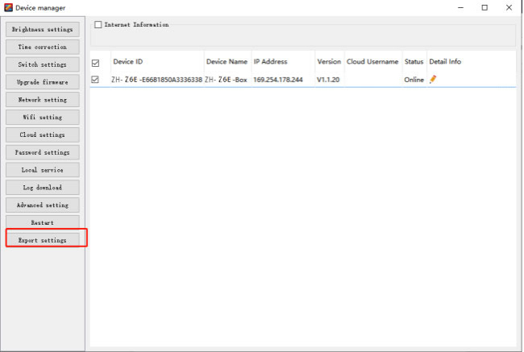

③ Choose “Network Setting ” --- “WiFi Setting” --- “Enable”, make sure the WiFi name and password, then click “Export”--- “OK”. 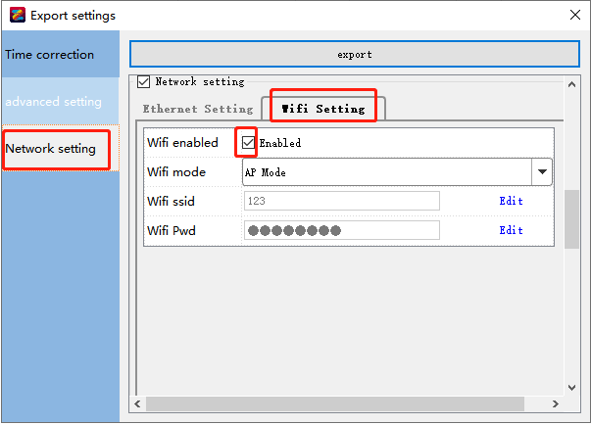

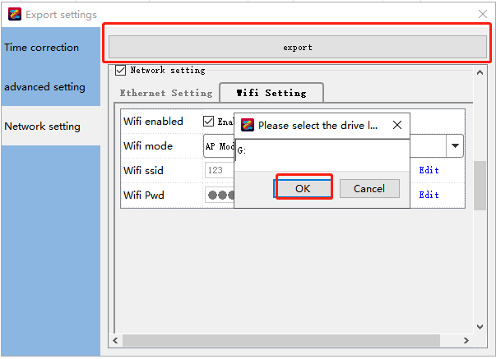

④ After link this WiFi can send content. (For the steps, please refer to the network cable sending)

